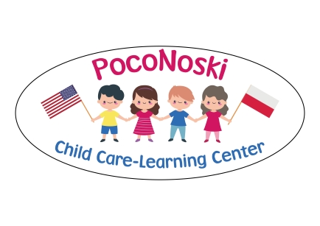

Handbook Agreement

I have received the PocoNoski Child Care Handbook, and
I understand and agree that it is my responsibility to read and familiarize myself with all the policies and procedures included.
I understand that it is my responsibility to go directly to the provider with any questions I may have regarding the policies, procedures and information contained in this handbook.
I understand that information contained in this handbook is subject to change with advanced notice.
Please sign this agreement and return to PocoNoski Child Care Center upon start date.

Parent/Guardian Name:____________________________
Parent/Guardian Signature:_________________________
Date:__________________________________________

